Assessment III
Nisanth. S
EmpNo.: 12576

Question:

Draw Class Diagram, Use Case Diagram, Sequence Diagram and Activity Diagram are Must.
ATM System - User Interactions: Which means the interactions between a bank customer (actor) and the ATM system. Use cases might include "Withdraw Cash," "Deposit Check," "Transfer Funds," "Check Balance," "Change PIN."
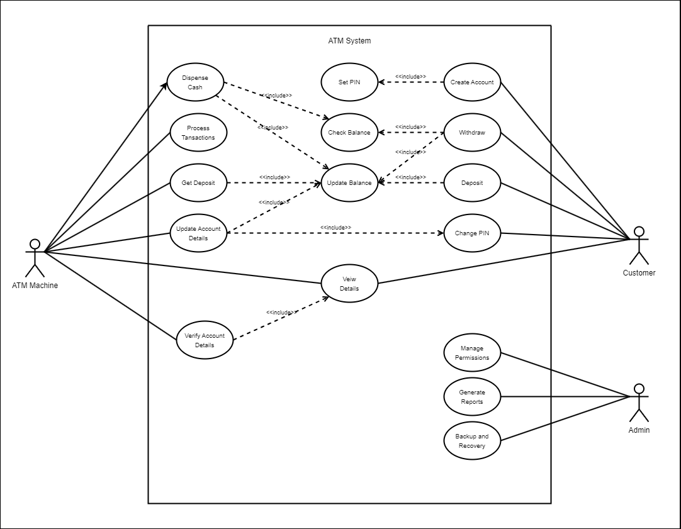
Use Case Diagram:

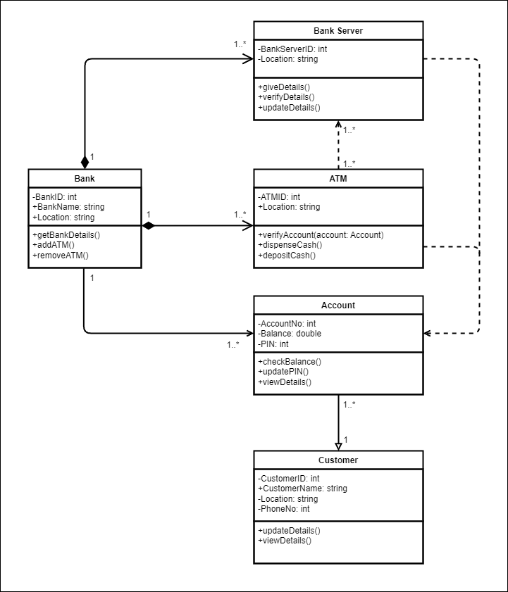
Class Diagram:
Activity Diagram:
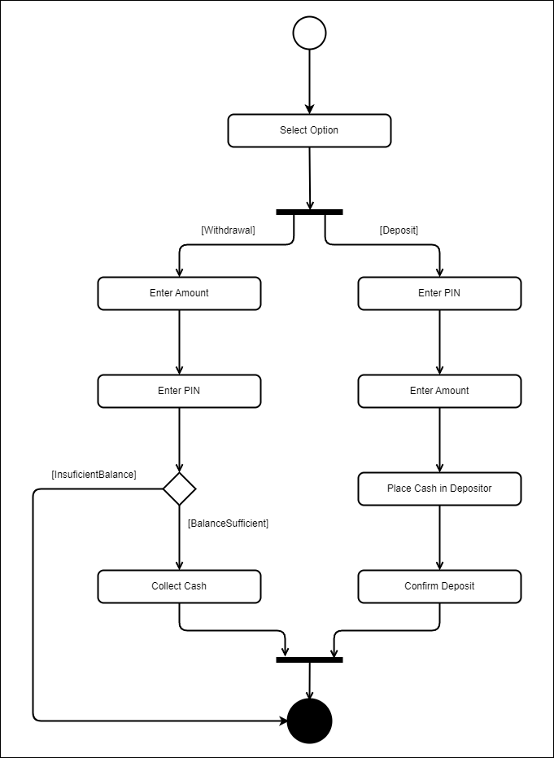
Sequence Diagram:
